Lesson 15
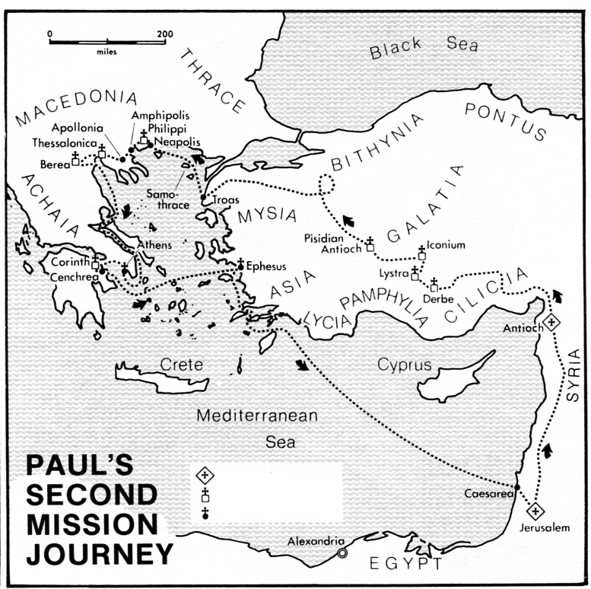
Acts 15:36 - 16:40
Paul’s Second Journey – More Open Doors!
Memory Verse: “They replied, “Believe in the Lord Jesus, and you will be saved—you and your household.”” Acts 16:31.

In this section, Luke reported Paul and Barnabas' efforts to strengthen the churches they had planted in Cyprus and Asia Minor to emphasize the importance of this phase of church extension. He also did so to set the scene for the next major advance of the church. Paul went next into the provinces around the Aegean Sea, some of which were on what we now call the European continent.
Upon arriving in Lystra, Paul and Silas are joined by Timothy, a young man, who the elders of the Galatian churches consider suited to the task ahead (1 Timothy 1:18; 4:14). Timothy is half-Jewish, and Paul thinks it wise that he be circumcised, apparently hoping this would gain acceptance for Timothy with the Jewish population wherever the missionaries go. The circumcision of Timothy is for practical, not religious purposes, in keeping with Paul’s principle that while working with the Jews he would live like the Jews so that he might win them for Christ (16:1-3; cf. 1 Corinthians 9:20).
Leaving Galatia they enter the province of Asia, but God does not allow them to preach there. They head north towards the province of Bithynia, but again God prevents them from carrying out their plans. So they head west across the region of Mysia to the town of Troas, from where they prepare to sail to Europe. Their destination is to be the province of Macedonia, the northern part of present-day Greece. These unexpected changes in Paul’s missionary movements show that although he knows the importance of planning his work, he also knows the importance of obeying God whenever he directs him in a different direction (16:6-10).
The missionaries leave Troas with another addition to the party, Luke, the author of the book (note the word ‘we’ in verse 11). Luke’s home appears to have been in Philippi, the city to which the group is now heading (16:11-12). It seems that Philippi has few Jews and no synagogue, but a group of God-fearers meet for prayer at the river bank. The missionaries join with them and make known to them the gospel of Jesus Christ. As a result a cloth merchant named Lydia becomes a Christian and, through her, her household also believes (16:13-15).
For the apostle Paul, the church at Antioch was not a parking lot: it was a launching pad. He could never settle down to a “comfortable ministry” anywhere as long as there were open doors for the preaching of the gospel. In this second journey of Paul, it indicated that God was still at work, in spite of the seeming obstacles and personal difficulties that arose.
Paul would have agreed enthusiastically with the words of Robertson McQuilken from his book The Great Omission: “In a world in which nine out of every ten people are lost, three out of four have never heard the way out, and one of every two cannot hear, the church sleeps on. Could it be we think there must be some other way? Or perhaps we don’t really care that much.” Paul cared—and so should we.

Scriptural Reading: Acts 15:36-41; 16:1-15; 25-31.
Things to learn: 1) God overrules for His purposes. 2) God’s servants used wisely. 3) The Triune God is still working.
Read the introduction to this study and Acts 15:36-16:40
Questions:
1) What can we learn about God’s purposes in the conflict between Paul and Barnabas from Acts 15:34 – 41?

2) How did Paul use his co-workers when they ministered to the churches of Galatia in Acts 16:1-5?

Q3 How can we be encouraged by the three wonderful “openings” (into Europe not Asia vvs. 6-12; Lydia’s heart vvs. 13-15; prison doors vvs. 16-40) as recorded in Acts 16:6-40?

