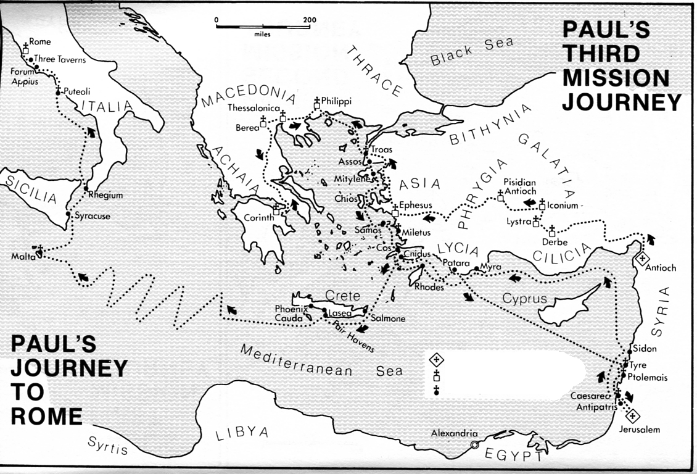
Lesson 19
Acts 20
A MINISTER’S FAREWELL
Memory Verse: “Even from your own number men will arise and distort the truth in order to draw away disciples after them.” (Acts 20:30 NIV)

At the end of Paul’s three years in Ephesus he travels north to Troas and then across to Macedonia (20:1). After meeting Titus and writing Second Corinthians, Paul moves around other parts of the region and then heads south towards Achaia (20:2). In due course Paul arrives in the south of Greece and stays there three months (see 20:3). No doubt he spends much of this time with the church in Corinth (2 Corinthians 13:1), for he wants to be assured that it is stable and strong before he expands his work to the west (2 Corinthians 10:15-16). From Corinth the next base in his planned move westward is Rome (Acts 19:21).
Although Paul is planning to visit Rome, his immediate concern is to go to Jerusalem with the money he has been collecting from the Gentile churches (Romans 15:24-26; Acts 19:21). Just as he is about to set sail, he hears of a Jewish plot to kill him, so he changes his plans and returns through Macedonia (20:3). In Macedonia, probably at Philippi, Luke re-joins the party. They then sail across to Troas, where they join the representatives of the Gentile churches who are to go with Paul to Jerusalem (20:4-6; cf. 1 Corinthians 16:3).
It seems that, by this time, Sunday has become a special day for Christians, when they met for fellowship and worship (20:7; cf. 1 Corinthians 16:2; Revelation 1:10). During Paul’s final meeting with the Christians in Troas, the all-night discussion is interrupted when a young man falls out of a window to his death; but Paul restores him to life (20:8-12).
From Troas Paul goes by land to Assos, where he re-joins the rest of the party and sails to Miletus (20:13-16). Since Miletus is only about fifty kilometres from Ephesus, Paul takes the opportunity to call the elders of the Ephesian church to come and meet him. He wants to give them some final encouragement and pass on helpful warnings (20:17). Paul’s opponents in Asia have probably been trying to turn the Christians against him. Therefore, he reminds the Ephesian elders of his tireless work in Ephesus and of the constant danger he faced from the Jews (20:18-24).
The Christians at Ephesus also are about to be shaken by serious troubles. Paul knows that, in spite of his preaching in Ephesus, people both from within the church and from outside will try to destroy the work of God in that city. The elders will need to be watchful, understanding, hard-working and strong if the church is to withstand Satan’s attacks (20:25-31). Paul reassures the elders that by God’s grace and through His Word they would be built up. He also reminds them that, like him, they are to sacrifice their rights and comforts for the sake of others, and never use their position of leadership for personal profit (20:32-38).
This chapter describes three “farewell events” as Paul closed his ministry in Macedonia, Achaia, and Asia. Paul is determined to finish his course with joy, no matter what the cost might be (Acts 20:24).

Scriptural Reading: Acts 20:1-38
Things to learn: 1) An Admirable Christian Character 2) A Typical Christian Meeting 3) A Charge to spiritual leaders.
Read the introduction to this study and Acts 20
Questions:
Q1. What do you think of Paul’s character at this stage of his travels from verses 1 to 6? (10 minutes discussion)

Q2 Luke gives us a brief report of a local church service in Troas. Can we learn something of how they met and worshipped the Lord. (vvs 7-12)?

Q3. Review the farewell message of Paul and the instruction he gives for ministry spiritual leaders (Acts 20:15-38). Compare yourself against this charge to the spiritual leaders, what encourages you?

